Exercise 2 - Carroll’s Pyramid of Corporate Social Responsibility

In this exercise, you are required to apply Carroll’s model of Corporate Social Responsibility to identify examples of the four areas of responsibility that drive your organisation’s actions and decisions. Summarise your findings by completing the template below.

Carroll’s Pyramid of Corporate Social Responsibility (1996)

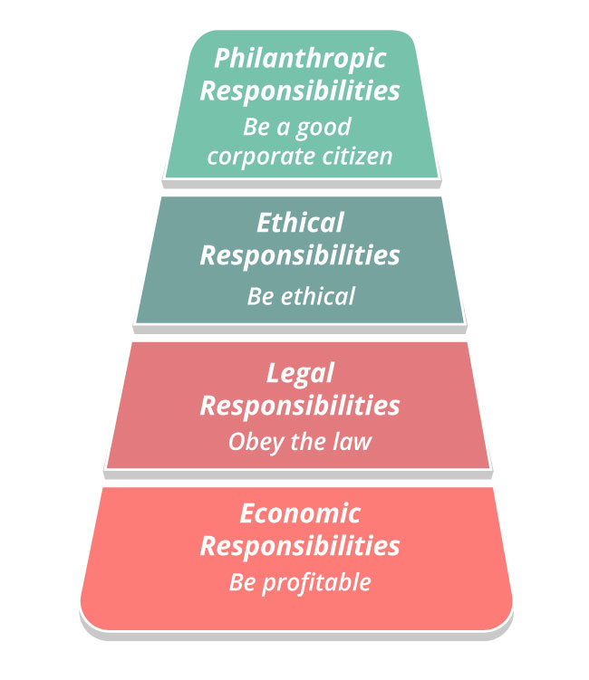

Identify between three and five examples (actions and/or decisions) that relate to each of the four areas of responsibility illustrated by Carroll’s model of Corporate Social Responsibility.
Philanthropic
Ethical
Legal
Economic

